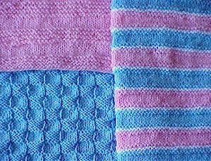
15" BLANKETS

Simple enough for a beginner, quick to make for an experienced knitter; these blankets are great for doll blankets and preemie baby charities. Double the cast on number and knit a full sized, 30" baby blanket.
MATERIALS:
3 oz. of Baby or Sport weight yarn --- for each
of the solid colour blankets
1 oz. each of 3 colours for the striped blanket
#6 straight knitting needles

GAUGE: 5 sts/7 rows = 1"
(stocking stitch)
PATTERNS:
Garter Stripes:
Rows 1-5: Work Stocking Stitch (K on Right Side, P on Wrong Side)
Rows 6-12: Work Garter Stitch (K every row)
Repeat rows 1-12 for pattern.
Basket Weave:
Row 1: P5, K5 across
Rows 2-5: K the K sts, P the P sts across
Row 6: K the P sts, P the K sts
Rows 7-10: K the K sts, P the P sts across
Repeat rows 1-10 for pattern.
Raised Garter Stripes:
Rows 1 & 2: With color B, K across
Rows 3-6: Work Stocking Stitch (K on Right Side, P on Wrong Side)
Rows 7 & 8: K across; change to color A
Rows 9 & 10: With color A, K across; change to color C
Rows 11 & 12: With color C, K across
Rows 13-16: Work Stocking Stitch (K on Right Side, P on Wrong Side)
Rows 17 & 18: K across; change to color A
Rows 19 & 20: With color A, K across; change to color B
Repeat Rows 1-20 for pattern.
INSTRUCTIONS:
For each blanket:
A. CO 75 sts. Work 7 rows (4 ridges) of Garter Stitch (K every row).
B. Work first 5 and last 5 sts in Garter Stitch, with one of the three patterns above, in
between.
C. When blanket measures 14" from start, work last inch (approx. 7 rows -- 4 ridges) of
Garter Stitch. CastOff.

Waffle Premmie Blanket

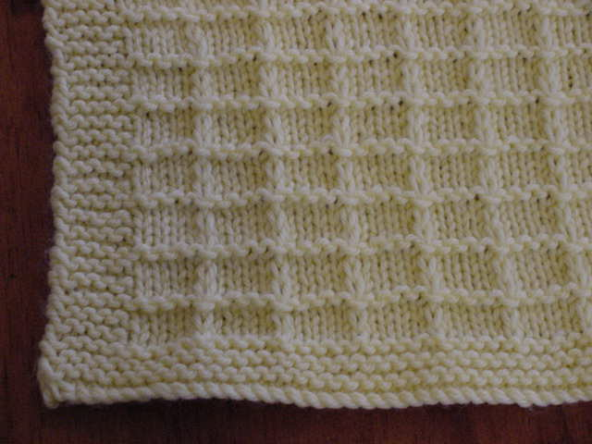

Needles: 4mm Yarn: 8ply or DK (Note: tension will be slightly different with a DK) Cotton, Acrylic or Baby Wool
Tension: 22 sts/10cm (8ply)
Sizes: | x-small | small | med | large
cm: | 50X50 | 70X70 | 90X90 | 110X110

Cast on 109 (154, 199, 235) sts
6 Rows of garter st
Row 1. K5, *K5, slip 1 st purlwise with yarn at back of work, rep from * K9
Row 2. K5, purl till last 5sts, K5
Row 3. Repeat row 1.
Row 4. Repeat row 2.
Row 5. Repeat row 1
Row 6. As for row 1 again.
These 6 rows form pattern, continue till reach about 47 (67, 87, 107) cms.
6 rows of garter st.
Cast off.

Angel Pocket
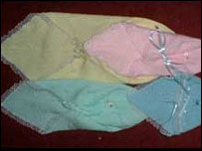
This Angel's Pocket is knitted in 4 sizes. It is used on the labour suites for tiny babies who do not make it. Some of these babies are very small and / or fragile, so these little wraps are used.
Please use wool no thicker than 4 ply in white or any pastel colour. 3 or even 2 ply is fine especially for the smaller ones. Use the larger sizes and adjust needles to suit. They will of course come out smaller.

In 4 ply wool Size 9 needles 3.3/4mm
The finished size does not matter but here are the approximate finished sizes and weights
Size 1 - 17cm [61/2"]square | 20gm [1/2oz]weight
Size 2 - 22cm [9"] | 30gm [1oz]
Size 3 - 28cm [11"] | 40gm [11/4oz]
Size 4 - 33cm [13"] | 70gm [21/4oz]

SQUARE :-[mitred]
CAST ON 75, [101] [125] [151] stitches
1st row Wrong Side
Knit to centre 3 stitches Slip 1,knit 2 together, pass slip stitch over, knit to end of row
2nd row Knit.
Repeat these two rows until 3 stitches remain
Next row :- Slip 1 knit 2 together Pass slip stitch over. Fasten off.

TRIANGLE :- [mitred] This forms the pocket
At the cast on edge of the square [2 sides] Pick up 75, 101, 125. 151. stitches
1st row:- Wrong Side
Knit 2 together, knit to centre 3 stitches Slip 1. knit 2 together, pass slip stitch over, knit to the last 3 stitches, knit 2 together knit1.
2nd row :- Knit
Repeat these 2 rows until 7 stitches remain
Next row Knit 1, knit 2 together knit1, knit 2 together. Knit1
Cast off remaining 5 stitches.
To finish off sew lace round the 3 raw edges or you can crochet any suitable edging. Cut ribbon, or make a cord or crochet chain. 16" 18" 20" 22". Using either a large eyed bodkin or medium sized safety pin. Thread the ribbon/cord from the right hand seam across the front pocket and out through the left hand seam. Gather up pocket and
tie in a bow. If you wish to put a little motif or bow etc on please do so.

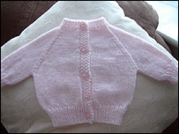
2 Needle Cardigan

NOTES: Here is a little 16” cardigan with just one arm seam - for those of you who don't like working on 4 needles!

All in one Neck-down Cardigan
1 pair 3.25m needles (Old size 10) Less than 50 grams 4 ply baby wool Contrast wool to make markers

Abbreviations PM Place marker (loop of contrast wool)

Main Part
Cast on 58 stitches Work 3 rows in K1 P1 rib**{{On the 4th and following 18th rows, make buttonholes on left or right, depending on whether cardi is wanted for boy or girl, till you have 4 buttonholes}}**Work 2 more rows in K1 P1 rib.

Place markers as follows
1. MS 5, K9, Place marker, K6 PM, K18 PM, K6 PM, K9 MS 5
2. MS 5, purl across (passing markers to other needle) to last 5, MS 5
3. (Increase row) MS 5, knit across BUT increase in the stitches before and after each marker, to last 5, MS 5 {(to make increases without producing holes, knit into BACK then FRONT of each increase stitch)} (64 sts)
4. MS 5, purl across to last 5 sts, MS 5

Repeat rows 3 and 4 (increasing 8 stitches every increase row) until you have 178 stitches arranged as follows.. 29 // 36 // 48 // 36 // 29

First sleeve
Next Row, dividing for sleeves With right side facing MS 5, Knit 60, Turn and Purl 36 sts.
Work 18 rows of stocking stitch on these 36 stitches
Next row, decrease 8 times evenly across row (28 sts)
Work 8 rows of rib, and cast off

Second sleeve
With right side facing Rejoin yarn, and knit across back and sleeve stitches (84 sts)Turn and purl 36 sts
Work 18 rows of stocking stitch for 2nd sleeve, and complete to match first.

Completing main body

With right side facing Rejoin yarn, and knit across the 29 sts for front
Next row, purl across, keeping the Moss stitch borders
Keeping the 5st MS borders, work 18 rows stocking stitch (remembering button holes as before)

Next Row – decreasing for welt. MS 5, k2, (K2tog K3) to last 5 sts, MS 5
MS 5, purl across to last 5 sts, MS 5

Work 8 rows in K1 P1 rib, pacing 5th buttonhole half way down bottom rib. Cast off

Hat for premature babies

4-ply wool; No 3.25mm (10) needles

Cast on 53sts and work in moss stitch for 6 rows.
Row 7: *k3, yfwd, k2tog* Repeat *to* until last 3 sts, k3
(Row 7 forms a row of eyelets holes, in case tubes need to be threaded through in hospital.)

Main part of hat
Continue in moss st. for 25 more rows.

Shape crown.
!st crown row: k7sts. *K2tog, k5* repeat *to* to last 4 sts, k2tog k2 (46 sts)
2nd and every alternate row: Purl

3rd crown row: k6sts. *K2tog, k4* repeat *to* to last 4 sts, k2tog k2 (39sts)

5th crown row: k5sts. *K2tog, k3* repeat *to* to last 4 sts, k2tog k2 (32sts)

7th crown row: k4sts. *K2tog, k2* repeat *to* to last 4 sts, k2tog k2 (25sts)

9th crown row: k3sts. *K2tog, k1* repeat *to* to last 4 sts, k2tog k2 (18sts)

11th crown row: *K2tog, k1* repeat *to* end. (12sts)

To make up
Break off yarn, run through remaining stitches, draw up and fasten off. Join up seam.

